BHASHADAAN USER DATA ANALYSIS REPORT
(17-01-26 to 17-04-26)
1. SUMMARY
- User Registration Data: A total of 91 records were captured in the User Registration spreadsheet. This reflects the number of individuals who signed up to engage with the platform during the period.
- Contribution Data: The Contribution Counts spreadsheet recorded 571 entries, representing the volume of user activity and participation across the platform.
- Insights: The data highlights both the growth in user registrations and the level of contributions made. This dual perspective provides valuable understanding of how users are interacting with Bhashadaan.

2. INSIGHT REPORT
2.1 User to Contributor:
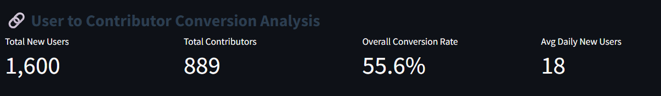
Best Converting Month: March 2026 Conversion Rate: 59.6% New Users: 475 Contributors: 283
Lowest Converting Month: January 2026 Conversion Rate: 50.9% New Users: 230 Contributors: 117
The upward trend from January to March indicates improved user engagement and effectiveness of onboarding strategies, although a slight decline is observed post-March.
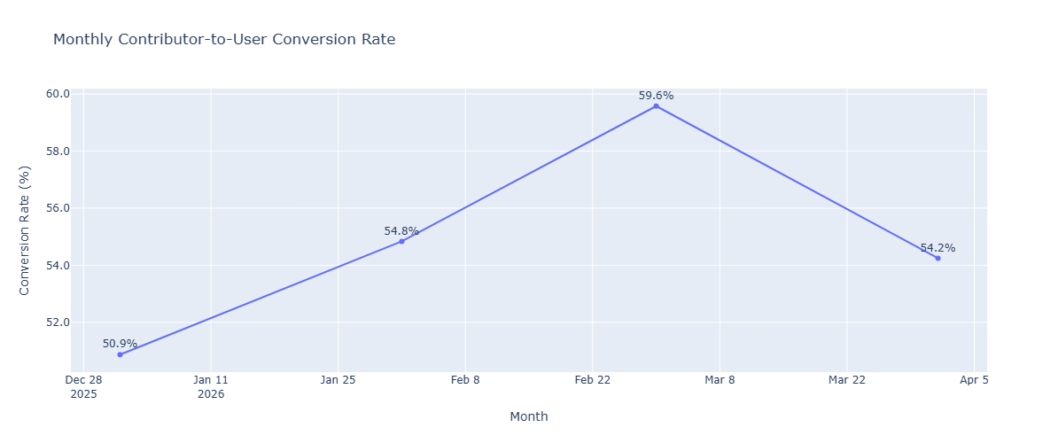
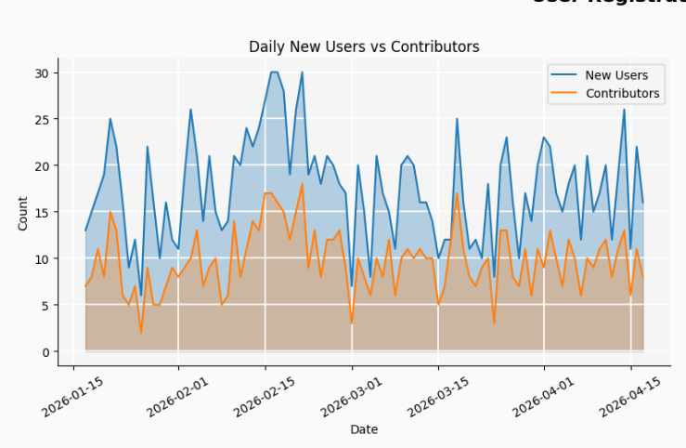
Most new users registered : 2026-02-16 (30)
Most contributors recorded : 2026-02-21 (18)

2.2Contributor analysis daily and weekly basis
Top activity days of users recorded shailendra.dic@digitalindia.gov.in
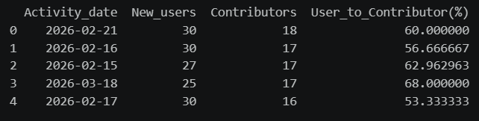
Mostly the conversion rates are higher than the average. Notably, 18 March 2026 achieved the highest conversion rate. In general February has most activity recorded.
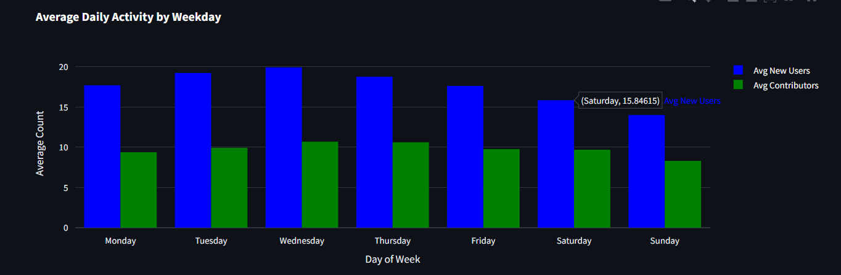
The average daily activity across weekdays shows a clear behavioral trend:
- Mid-week (Tuesday–Thursday) records the highest user and contributor activity.
- Wednesday shows peak engagement in terms of both new users and contributors.
- Weekends (Saturday–Sunday) experience a noticeable drop in activity.

2.3 Monthly Contribution Analysis :
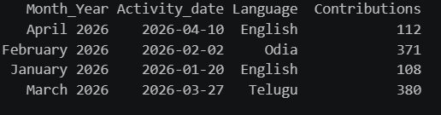
These are the dates in each month on which most activity was reported
- March 2026 recorded the highest single-day contribution (380), closely followed by February. Meanwhile overall February has recorded the most contributions
- A significant surge in contributions is observed in regional languages such as Odia and Telugu, indicating strong participation beyond dominant languages.

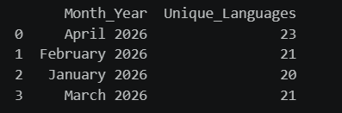
The number of unique languages contributed each month reflects the diversity of user participation across the platform. In terms of language diversity April has most diverse contributions.

2.4 Language Diversity
Over the last four months, the majority of contributions were concentrated in:
- English (30%)
- Hindi (12%)
- Kashmiri (12%)
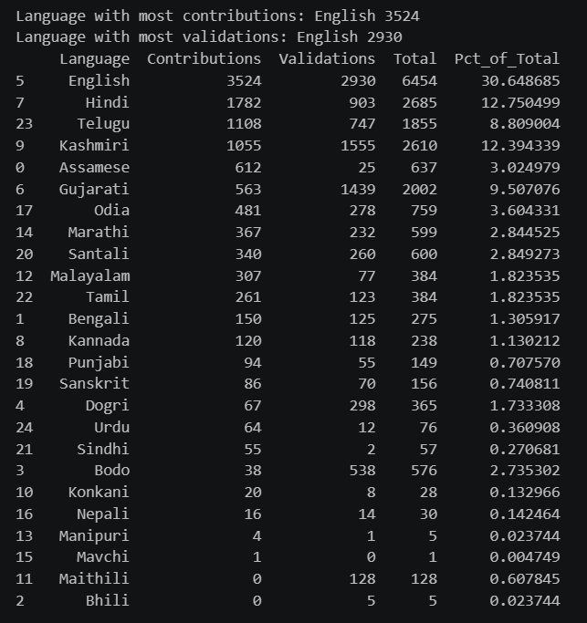

2.5 Contributions vs Validations
- Consistent Gap Across Months:
In every month, contributions exceed validations, indicating that not all submitted data is immediately validated. This reflects the natural lag in the validation pipeline.
- Largest Gap in High Activity Period (February):
February shows the widest gap between contributions (4831) and validations (4243).
→ This suggests that during peak activity, the validation system struggles to keep pace with incoming data.
- Gap Reduces Over Time:
From February → March → April, the difference between contributions and validations steadily decreases.
→ This indicates improved validation efficiency or reduced pressure on the system.
- April Shows Near Balance:
In April, validations (2084) are very close to contributions (2160).
→ This suggests a well-balanced system where most contributions are being processed and validated promptly.
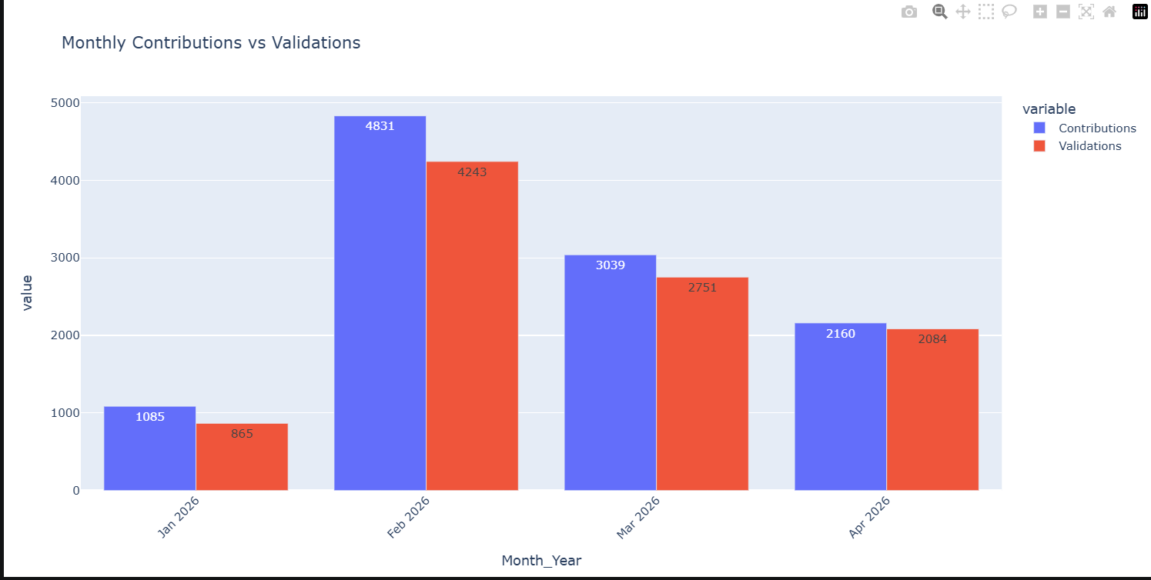

2.6 Language-wise Validation
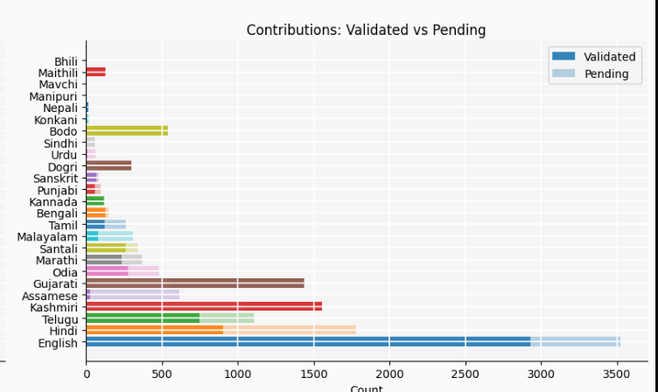
Some languages have a large gap where contributions are much higher than validations, meaning a lot of data is still unverified.
1. High Backlog Languages (Low Validation Coverage)
Some languages have a large gap where contributions are much higher than validations, meaning a lot of data is still unverified:
- Hindi: 1782 contributions vs 903 validations (~49% pending)
- English: 3524 vs 2930 (~17% pending, but large absolute backlog)
- Kashmiri: 1055 vs 1555 (interesting case, see below)
- Telugu: 1108 vs 747 (~32% pending)
- Odia: 481 vs 278 (~42% pending)
- Malayalam: ~75% still pending
2. Over-Validated Languages (Validations > Contributions)
Some languages show more validations than contributions, resulting in negative “remaining” values:
- Bodo, Dogri, Gujarati, Kashmiri, Maithili
- Bodo & Dogri show extreme negative percentages → likely backlog clearance or data anomaly
- Maithili has 0 contributions but 128 validations.

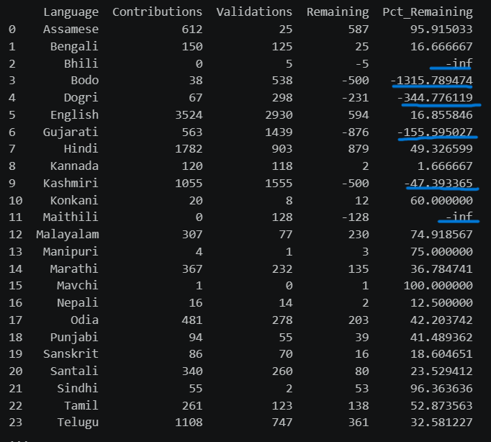
Highlighted data shows ambiguity in validation and contribution data.

RECOMMENDATIONS
- Track Active Users & Churn Rate:
Introduce a “current active users” metric to monitor retention and identify drop-off points in user engagement.
- Capture User Location Data:
Adding location information will help map region-wise language contributions and target specific linguistic communities more effectively.
- Enhance Language Diversification:
Focus on increasing contributions in underrepresented regional languages to better align with the platform’s inclusivity goals.
CONCLUSION
- February 2026 recorded the highest overall interactions, marking the peak of user engagement on the platform.
- A declining trend in contributions is observed after February, indicating a drop in sustained user activity.
- March 27, 2026 recorded the highest single-day contribution, highlighting strong but short-term activity spikes.
- April 2026, despite lower overall contributions, showed the highest language diversity, indicating broader participation across different linguistic groups.
- The majority of contributions were concentrated in English, Hindi, and Kashmiri, making them the dominant languages on the platform.
- Mostly users contribute in English and hindi language which adds little value in our mission.
- A significant gap between contributions and validations is observed, especially during high-activity periods like February. This suggests that the validation system struggles to keep pace with incoming data, leading to backlog accumulation.
- Found ambiguity in data where in some cases language validation dataset exceeds number of contribution dataset.
- Overall, the platform demonstrates strong engagement with periodic peaks, along with growing multilingual participation, indicating potential for both improved retention and expanded language outreach.

